Objective Proposal

Group 1
Purva Bommireddy, Dylan Bonanno, Samuel Chen, Jane Fleischman, Alana Frederick, Paul Gonzalez, Antu Mageshwaran, Flannery McNair, Anusha Modi, Autumn Swartz

Department of Civil and Environmental Engineering
Carnegie Mellon University
Pittsburgh, PA
December 17, 2023

Executive Summary
This report focuses on a student-led redesigning of South Craig St in the Oakland neighborhood of Pittsburgh. Craig St is home to many businesses and is a common street for students to be traveling on. It has significant potential to be a bustling college street, but the current design of it does not make it friendly to pedestrians and cyclists. Many changes are proposed, including moving the location of the Forbes and Craig inbound bus stop, reducing the number of driving and parking lanes on the street, implementing bike lanes, widening sidewalks, and improving the aesthetics of the street to make it more inviting. The overall proposal is outlined in detail to clearly communicate what is proposed for each aspect of Craig St. Each of these choices are evaluated to determine their effectiveness and feasibility compared to what Craig St is currently like. We determined that with our redesign, the street would be more friendly to pedestrians, better equipped to support local businesses, and overall a better location to build community within the student body.

Table of Contents
Executive Summary 1
1.0 Introduction 3
2.0 Problem 4
3.0 Design Overview 5
3.1 Objectives 5
3.2 Constraints 5
3.3 Evaluation Criteria 6
4.0 Proposed Design 8
4.1 Overview 8
4.2 Traffic 8
4.3 Sustainability 10
4.4 Environment 10
5.0 Conclusions 13

Introduction
Craig Street, as many may know, is a commonly used street for CMU students and surrounding community members. Housing student staples such as Starbucks, Sushi Fuku, Eatunique and some university buildings, there is no question that this area could appeal to many. However, after assessing it as a group we have noticed that it is underutilized because of factors including its small sidewalks, few places to sit, poor curb appeal, and traffic congestion.
In response to the pressing challenges faced by urban transportation infrastructure, this report unveils a comprehensive project aimed at revitalizing Craig Street, a vital corridor stretching between Fifth and Forbes Avenue. The overarching objective is to compile the principles of each of the stakeholder groups intricately linked to Craig Street which includes; road safety, cycling, green infrastructure, traffic engineering, transit, urban planning, policy, development, and the student experience. Throughout our collaboration we were able to find a transformative way to redesign Craig Street where each stakeholder group brought their own insights and we finalized a design we believe to be the best possible outcome. This report follows our team's process, constraints we had, decision making, data collection and analysis in efforts to create a better Craig Street.

Problem
South Craig Street, or the section of Craig Street between Forbes Avenue and Fifth Avenue, sits between the main campus areas of both the University of Pittsburgh and Carnegie Mellon University. Its location, combined with the restaurants and community spaces that line the street, give it the potential to be a Great College Street, serving as a campus gateway and enhancing CMU’s connections to the Oakland neighborhood. However, at present, South Craig is held back by a variety of factors. Its sidewalks vary significantly in width, with some spaces having very little sidewalk space, making it less accessible to pedestrians; there are minimal seating areas along the street; and traffic along the street is very congested and makes the street unfriendly toward pedestrians, a group that includes most students who use the area. Through the lens of the 2022 Institutional Master Plan’s principles of Design, Experience, Mobility, Context, and Opportunity, we can make a variety of improvements to the South Craig area – creating a memorable, integrated, and connected campus space that fosters a sense of community, collaboration, and growth.
In this project, we are responsible for proposing a compelling overhaul of the South Craig area. In order to formulate our proposal, we must collect and interpret traffic data as well as data on the other stakeholders involved, interact and discuss our findings with a professional mentor representing a stakeholder community, and balance the interests of the various stakeholder groups involved in South Craig. With these interests and the data in mind, we will create a proposal that serves as much of the community as possible, with minimal disruptions. To do this, we must examine and understand the implications of our proposed solution to the community, and ensure that our proposed solution meets the needs of the community at large with minimal adverse impacts.

Design Overview

Objectives
For our proposal, our biggest objective was to improve the streetscape for pedestrians and cyclists to make it more accessible and safe for students. We believe that streets can serve as public spaces and are vital for businesses, so we wanted to do everything to make this a reality. Currently, Craig Street caters first and foremost to users of the automobile, despite the fact that only 30% of CMU students own a private vehicle. Furthermore, according to the development group, 91.7% of Craig Street foot traffic is from students. Because of this, our group wanted to focus on making a design that is the safest and most appealing for these students and others without a vehicle since they use the street the most. By making the street more like a public space, people outside of vehicles will feel comfortable sticking around and just hanging out in the area. This will end up improving economic activity as well because as more people hang out at Craig, more money will end up being spent at its businesses.
An additional objective of our design was to keep costs low and construction times down while also implementing at least one idea from each stakeholder group. At the end of the day, our group found that there was not too much conflict if we wanted to implement almost every idea from each group. If we did this, however, the costs and timeline of such a project would be impractical. For example, the development group wanted to create a parking garage to replace street parking, which ended up in our final design. They also wanted to develop 300 Craig Street into “Fusion Square,” which would be a new center for CMU students to study and dine on Craig. Although both were good ideas, we chose to only include the parking garage because we felt it would do the most to bring more people to the street and improve its liveliness. It would also have cascading positive effects like allowing us to widen sidewalks as much as possible. Costs were further reduced by allowing businesses to use this extra space as they pleased. We could have also invested in things like outdoor seating, but we believed it is up to us to make the street generally very inviting, and up to businesses to invest in their own outdoor spaces.

Constraints
In a project like this, a big constraint is often city laws and regulations that already exist that limit what can be done such as zoning laws preventing mixed use developments. Craig Street falls under OPR-B zoning, which is pretty progressive by American standards. It promotes active uses in ground floors of buildings, such as restaurants, while upper floors are primarily office or residential. These ground floors also have no required setbacks and require a lot of transparency for passersby. Additionally, no accessory surface parking is permitted. Fortunately, according to the policy group, our design is compliant with laws and regulations within the city of Pittsburgh. One policy constraint considered was a dark sky ordinance that limits light pollution. We took this into account by ensuring our new street lighting points downwards. Another example is an ordinance that prohibits parking in bike lanes. Our group decided to remove all of the street parking, which allowed us to, in addition to other benefits, add a bike lane on either side of the street. Finally, parking minimums did not simply allow us to just get rid of the parking; we are building a parking garage that will replace the parking that we removed.
In addition to existing policy, land ownership is another important constraint. We could not change buildings that were not owned by CMU or Pittsburgh unless we bought them out. Luckily, a lot of our proposed changes occur on the actual streets and sidewalks, which are owned by Pittsbutgh. Our proposed changes also do not violate any of their traffic laws. Other than that, we developed land that was already owned by CMU. For example, the new parking garage will be in an existing parking lot owned by the University. It is also our only proposed structure, and will mostly follow the designs of existing parking garages such as Dithridge Street. This will be to avoid any constraints on materials or violations of other regulations. Additionally, this lot will be located at the intersection of Zebina and Winthrop streets, which is outside the limit of OPR-B and instead in EMI, which allows surface lots. The maximum height of the garage in this zone is loosely defined, but will comply with the 60’ limit on Craig.
Finally, as mentioned in the objective, we have a couple constraints we made for ourselves as well. We wanted the project to be relatively cheap while also making at least one improvement for each stakeholder group. It would be possible to just buy out the entire street and do exactly what we want, but this would be enormously expensive and could take unacceptable amounts of time.

Evaluation Criteria
To measure our design and other alternatives considered, we used a weighted scoring system. Our team came up with a list of objectives and constraints that we found important and then ranked them by how important they were to us. This guided how much to weigh each item, with the weight limited to being from 1-5. The weight works by multiplying the score given to each item with the weight to get a weighted score. Each item is scored from 0-5 with 0 being not satisfied at all and 5 being the most satisfied. The following table is what our group used to quantify the costs and benefits of each alternative considered:
Criteria | Weight | Score Meaning
Pedestrian Experience | 5 | 0 - Craig still caters to cars  5 - Street completely pedestrianized
Cyclist Experience | 3 | 0 - No bike infrastructure/worse  5 - Amsterdam
Safety | 5 | 0 - No improvements  5 - Full traffic calming implemented (raised crossings, narrow street, chicanes, etc.)
Stakeholder Acknowledgement | 4 | 0 - Only one stakeholder satisfied  5- All stakeholders satisfied
Costs | 4 | 0 - Costs in the hundreds of millions  5 - Costs under $30M
Time | 3 | 0 - Years to construct  5 - Months to construct
Legality | 5 | 0 - Proposal violates multiple laws  5 - Proposal violates no laws
Street Beauty | 3 | 0 - No changes/worse  5 - Many changes such as night lighting and green spaces
Economic Activity | 3 | 0 - No changes/worse  5 - Everyone shops at Craig Street
Traffic | 2 | 0 - No changes/worse  5 - Traffic moves at LOS A
TOTAL POSSIBLE | 185
Table 1: Criteria, Weight, and Scoring for Evaluation

Proposed Design

Overview
The proposed redesign of Craig St in Pittsburgh's Oakland neighborhood aims to transform the thoroughfare into a more sustainable, pedestrian-friendly, and aesthetically pleasing urban space. The traffic-focused measures consist of significant enhancements to bike infrastructure, alterations to bus stops, and the strategic decision to maintain the street as a two-way thoroughfare. Introduction of dedicated bike lanes, relocation of bus stops, and discontinuation of street parking contribute to a comprehensive traffic update. The sustainability aspect focuses on replacing crosswalk material with pervious alternatives, while the already proposed changes to the sidewalk allow for pockets of greenspace to be incorporated. Additionally, incorporating dedicated bike lanes promotes an alternative method of travel besides driving. Environmental considerations further enhance the proposal with improved lighting through strategically placed string lights and updated ADA truncated dome pads for enhanced accessibility. Overall, the proposal seeks to create a balanced and sustainable urban landscape that caters to the diverse needs of the community.

Traffic
The proposed redesign of Craig St prioritizes significant enhancements to bike infrastructure and alterations to bus stops, with a strategic decision to maintain the street as a two-way thoroughfare. In response to the needs of the community, the redesign introduces dedicated bike lanes on each side of the street, aiming to create a safer and more accessible environment for cyclists (Figure 1).

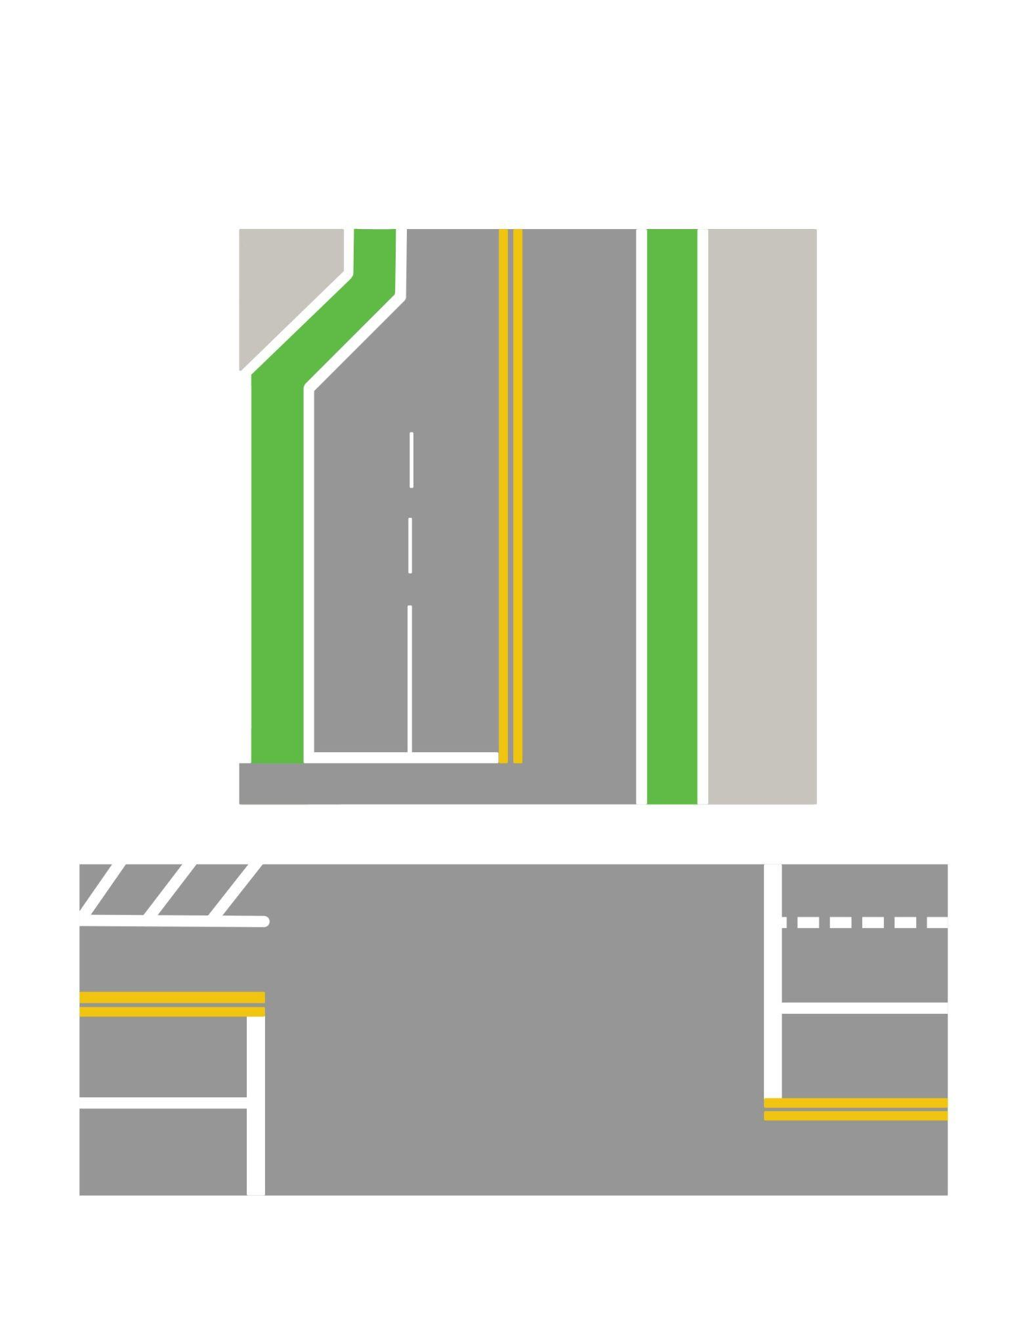
Figure 1. Forbes Ave. and Craig St. intersection with additional right turn lane, bike lanes, and widened sidewalk

To accommodate the creation of the bike lane and create a more pedestrian-friendly atmosphere, the redesign necessitates the discontinuation of street parking along Craig St. This decision allows for the expansion of sidewalks, the addition of bike lanes, and the installation of necessary transit infrastructure. In lieu of street parking, the plan includes the construction of a new garage in the existing parking lot behind TCS (FIgure 2), addressing the ongoing demand for parking spaces in the area.
Another goal of this redesign was to improve the public transit options. Ultimately the decision was made to not have any buses go on this section of Craig St, but modifications are proposed for the bus stop at the corner of Forbes and Craig, specifically in the downtown direction. The relocation of this bus stop 300 feet back toward the Carnegie Mellon campus is designed to create a safer place for riders to wait for the bus. The current Forbes-Craig inbound stop was of great concern because of the already narrow sidewalk and trash dumpster. Additionally, low-profile shelters comprising a roof and bench will be installed at the two bus stops at Fifth and Craig, enhancing the comfort and convenience of waiting passengers.
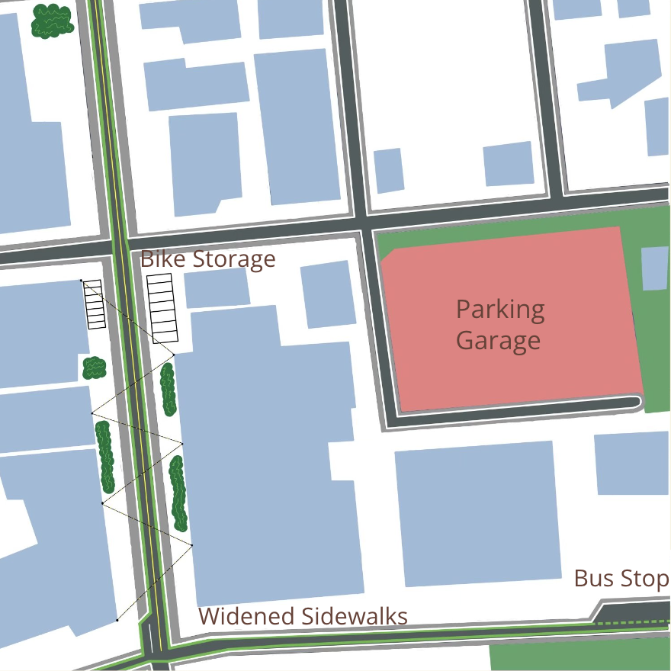
Figure 2. Overview of proposed solution including parking garage, bus stop, bike storage, and widened sidewalks.
Finally, the decision to keep Craig St as a two-way street is grounded in SYNCRHO modeling, which analyzed traffic flow and provided level of service (LOS) grades for the current traffic flow as well as a one way scenario and the improved design proposed in this report (Table 2). This modeling was based on data collected at seven intersections on November 7th. Results of the LOS study revealed no real difference between the one way and the improved solution, but when looking at the bigger roadway system a one way road would be too drastic of a change, and ultimately unnecessary. It is important to note that these conclusions are based on limited data and the decision to change to a one-way would require more data.
Intersections | LOS (Existing) | LOS (Improved) | LOS (one-way)
Forbes & Craig | C | C | C
Fifth & Craig | C | C | C
Forbes & Bellefield | B | B | B
Fifth & Bellefield | D | B | B
Table 2: Level of Service from Simulations Run on SYNCRHO

Sustainability
A significant aspect of this proposal involves replacing the existing crosswalk material with a pervious alternative. This would only impact the small areas where already existing sidewalks are located, but would provide a needed space for stormwater runoff to be absorbed. This is a significant investment, but is a crucial measure for Pittsburgh's infrastructure improvement. This change is motivated by the need to enhance the city's capacity to manage runoff effectively, aligning with broader sustainability goals.
Furthermore, the wider sidewalks proposed as part of the redesign not only accommodate increased pedestrian traffic but also provide an opportunity for the integration of green spaces along the sides of the road. These would consist of several longer breaks in the sidewalk where native plants would be planted. Incorporating these pockets of vegetation plays a crucial role in promoting biodiversity and mitigating the urban heat island effect. The inclusion of plants and greenery aligns with contemporary urban planning principles that seek to create more resilient and sustainable urban environments.
The introduction of dedicated bike lanes is also integral to the sustainability aspect of this design. Improved bike infrastructure promotes alternative and eco-friendly modes of transportation. These bike lanes would expand on the already existing bike lanes on Forbes Ave. Every change that increased the network of bike lanes in Pittsburgh makes biking a more viable option.

Environment
The proposed redesign of Craig St in the Oakland neighborhood of Pittsburgh includes a strategic focus on enhancing the pedestrian experience through the incorporation of wider sidewalks, green spaces, and improved lighting. The primary objective of widening the sidewalks is to create a more pedestrian-friendly environment, accommodating a larger number of people on both sides of the road. This expansion not only allows for increased foot traffic but also provides an opportunity to introduce green spaces along the street, as previously mentioned.
By integrating green spaces into the sidewalk design, the project aims to address the urban heat island effect. The addition of vegetation not only introduces aesthetic appeal but also helps mitigate the heat generated by urban infrastructure, promoting a cooler and more pleasant atmosphere. This approach aligns with broader urban planning goals of creating environmentally conscious and resilient city spaces.
In tandem with the sidewalk improvements, the proposal incorporates the installation of string lights along the road. These lights, while not excessively bright to violate dark sky mandates, are strategically placed to enhance the overall ambiance of Craig St. The intention is to create a visually appealing and inviting atmosphere, particularly for the student population and other pedestrians. The string lights serve both practical and aesthetic purposes, providing additional illumination for safety while contributing to the overall vibrancy of the street.
Finally, a very minor, yet impactful modification proposed is updating the ADA truncated dome pads at every intersection. This cost-effective adjustment ensures consistency and proper placement, enhancing accessibility for all pedestrians. By aligning with ADA standards, the redesign not only meets regulatory requirements but also underscores a commitment to inclusivity and accessibility in urban planning.

4.5 Criteria for evaluation
Our design has a total weighted score of 165. The exact numbers used are shown in Table 2. This score was a lot higher than other designs considered since the one we went with prioritized safety, pedestrian experience, and legality, which we thought were important. It also used a variety of ideas from each stakeholder group to come up with a well-rounded proposal that satisfies multiple criteria:
Criteria | Score | Weighted Score
Pedestrian Experience | 5 | 25
Cyclist Experience | 4 | 12
Safety | 5 | 25
Stakeholder Acknowledgement | 5 | 20
Costs | 4 | 16
Time | 4 | 12
Legality | 5 | 25
Street Beauty | 4 | 12
Economic Activity | 3 | 9
Traffic | 3 | 9
TOTAL |  | 165
Table 3: Final Design Scores

Conclusions
South Craig Street’s space is underutilized and does not live up to its potential to serve as a memorable and integrated campus space due to a variety of factors – narrow sidewalks, a lack of seating, and congested traffic all reduce its accessibility and appeal to the communities who use the space, despite its prime location between the campuses of Carnegie Mellon University and the University of Pittsburgh, as well as the Carnegie Museums. Our group has been tasked with proposing a compelling overhaul of the South Craig area using traffic data and balancing the interests of the various stakeholder groups involved in South Craig.
In order to design our proposal, there were some objectives and constraints to consider. First, we decided as a group that since much of the traffic on South Craig comes from automobiles despite its location, bringing pedestrians to the space would be a top priority. Additionally, since the area is in a busy section of Oakland, we needed to accomplish our goals and serve our stakeholder groups by minimizing cost and construction time to minimize disruptions to the community. On top of these objectives, our proposal needed to be compliant with city ordinances, which included zoning code, a dark sky ordinance minimizing light pollution, parking laws, and land ownership.
Ultimately, with these criteria in mind, our finalized proposal makes modest changes to South Craig. Regarding traffic congestion and pedestrian safety, we have chosen to keep the street two way, with one lane in either direction, but we will use all space currently occupied by street parking for wider sidewalks and bike lanes on both sides of the street. To comply with parking restrictions, we will instead increase the parking capacity of the lot behind TCS Hall to replace the lost capacity from street parking along Craig. Additionally, the inbound (downtown direction) bus stop at Forbes and Craig will be moved 300 feet back toward the CMU campus, to the courtyard in front of TCS Hall, and bus shelters will be added to stops at both ends of Forbes and Craig. Regarding sustainability, the crosswalks along the street will be replaced with pervious material and greenspace will be added in the newly-widened sidewalk to better handle stormwater runoff. Both these changes are relatively cheap to implement, but significantly improve South Craig’s ability to deal with severe storm events. Finally, to improve the pedestrian experience around the street, sidewalks will be widened (as mentioned previously), string lights will be added above the road to improve the street’s ambiance and lighting while remaining compliant with the dark sky ordinance, and more green space will be put in place in the newly-widened sidewalk to mitigate the urban heat island effect. Additionally, ADA-compliant truncated dome pads will be added along the sidewalks at all intersections to be consistent and located in the correct places.
Our proposal ultimately chooses to make several smaller, targeted changes that are all cost-effective but make meaningful improvement to the street and its surroundings, each of which will further our goals of improving the pedestrian experience while remaining cost-effective, compliant with all local and state laws, and minimally disruptive to the businesses currently operating along the street.

